12. Rotate an Image by 270 Degrees Clockwise Using OpenCV
Aim: To read an image in Python and rotate it by 270 degrees clockwise using OpenCV.
Procedure
- Import the OpenCV library.
- Read the input image.
- Rotate the image by 270 degrees clockwise using cv2.rotate().
- Display the original and rotated images.
Code
import cv2

img = cv2.imread("sample.jpg")

if img is not None:
rotated = cv2.rotate(img, cv2.ROTATE_90_COUNTERCLOCKWISE)

cv2.imshow("Original Image", img)
cv2.imshow("Rotated Image", rotated)

cv2.waitKey(0)
cv2.destroyAllWindows()
else:
print("Image not found")
Input
An image named sample.jpg saved in the same folder as the Python program.
Output

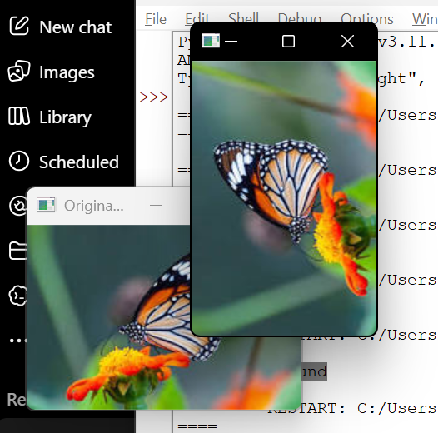
- Original Image: Displays the input image.
- Rotated Image: Displays the image rotated 270 degrees clockwise (equivalent to 90 degrees counterclockwise).
Result
The input image was successfully rotated by 270 degrees clockwise using the OpenCV cv2.rotate() function.

